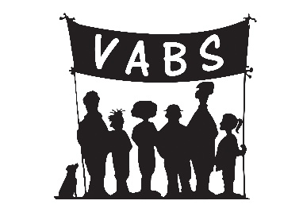

SUPPORTING COMMUNITIES FUND
Community Responses to Covid-19

FUNDING REQUEST FORM

Fund administered and distributed locally by
Voluntary Action Badenoch & Strathspey (VABS)

on behalf of Scottish Government
and Highlands and Islands Enterprise

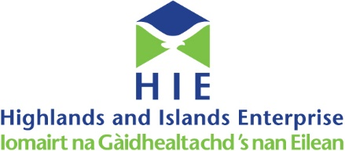
1. ORGANISATION/GROUP DETAILS
Name of your organisation/group:

Date it was set up:

Address and postcode of organisation/group:

Phone Number:

E mail:

Main contact name:

Contact’s position/role in the organisation/group:

2. LEGAL STATUS OF YOUR ORGANISATION/GROUP
Is your organisation/group…

Unconstituted 

Constituted 

Registered Charity 

What is the usual role/purpose of your organisation/group?

3. COVID-19 RELATED ACTIVITY DETAILS
Are you requesting funding for a new or extended activity since 16th March 2020? YES / NO

Please give us some details about your Covid-19 related activity

4. ACTIVITY COSTS
What specifically will the funding be used for?

Item Description | Cost
 | £
 | £
 | £
 | £
TOTAL COSTS | £

Over what period do you anticipate this activity will take place?

Have you applied to any other funds, for this or similar activity?

5. BANK ACCOUNT DETAILS
Name of Bank:

Address and postcode of Bank:

Account Name:

Account Number:

Bank Sort Code:

6. DECLARATION
I declare that to the best of my knowledge, all information given on this funding request form is true and accurate and confirm that I have read the guidance notes and understand and accept the terms and conditions noted within them. I also understand that supporting information may be requested at any stage of the funded period.

The data you have provided in the funding request and claim forms will be recorded on an electronic database and is subject to the Data Protection Act 2018.

Under the current circumstances, an electronic signature will be accepted. If this is not available, then please print name.

Signed:

Position held: Date:

Please return this funding request form by email to Karen or Ann at VABS
Details below

If you wish to discuss your funding request, with regard to eligibility or any other queries, please contact:

Karen Derrick
E: karenderrick@vabs.org.uk
T: 01479 870415
M: 07754 410644
Ann Traill
E: anntraill@vabs.org.uk
M: 07725 171280

